**ภาคผนวก ค**

**แบบทดสอบความสามารถในการอ่านคำศัพท์ภาษาอังกฤษระหว่างเรียน**

**แบบทดสอบวัดความสามารถในการอ่านและการเขียนคำศัพท์พื้นฐานภาษาอังกฤษ ก่อนเรียน จำนวน 30 ข้อ**

**แบบทดสอบก่อนเรียน**

**การจัดการเรียนรู้การสอนอ่านและเขียนภาษาอังกฤษด้วยวิธีการสอนแบบ 3Ps**

**รายวิชา ภาษาอังกฤษ กลุ่มสาระการเรียนรู้ภาษาต่างประเทศ ชั้นประถมศึกษาปีที่ 6**

**หน่วยการเรียนรู้ที่ 1 เรื่อง Under the sea เวลา 1 ชั่วโมงหน่วย**

**ใช้สอนวันที่ เดือน พ.ศ. ภาคเรียนที่ 2 / 2559**

**คำชี้แจง** จงเลือกคำตอบที่ถูกที่สุดเพียงข้อเดียว ข้อสอบมีทั้งหมด 30 ข้อ 30 คะแนน เวลา 60 นาที

Direction: Choose the best answer.

1. What word is the same meaning as ‘Octopus’?

a. shell b. rock c. squid d. fish

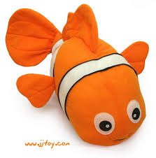2. Nana: What is this?

Tina: ……………. .

a. That is an orange fish. b. This is a orange fish.

c. That is a orange fish. d. This is an orange fish.

3. What is the opposite of “young”?

a. short b. old c. tall d. small

4. You are dirty. ………………. .

a. Don’t take a shower b. Takes a shower

c. To take a shower d. Take a shower

5. Find which one of four sentences does not belong.

a. Put your books on the floor. b. Close your eyes.

c. Take your shoes off. d. Don’t speak loudly.

6. …………………. It to me.

a. Giving b. Give c. Gave d. Gived

7. Don’t …………………… to me like that.

a. speaked b. to speak c. speaks d. speak

8. Don’t …………… away. Please ………………. For me.

a. runs, waits b. running, waiting

c. run, wait d. runed, waited

Look at the map and answer the questions 9-12.

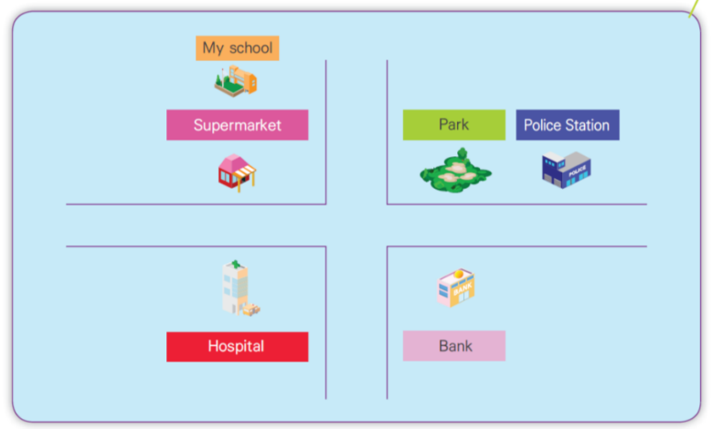

9. A : Where is the park?

B: ………………… .

a. It’s in front of the police station. b. It’s behind the police station.

c. It’s next to the police station. d. It’s opposite the police station.

10. Teacher: Where is the school?

Student: …………………… .

a. It’s in front of the supermarket. b. It’s behind the supermarket.

c. It’s next to the supermarket. d. It’s opposite the supermarket.

11. Choose the wrong answer.

a. The supermarket is opposite the hospital.

b. The police station is next to the park.

c. The park is behind the hospital.

d. The supermarket is in front of the school.

12. Choose the correct answer.

a. The hospital is behind the bank.

b. The bank is in front of the supermarket.

c. The police station is near the school.

d. The park is opposite the bank.

Direction: Choose the best answer to complete from the questions 13-16.

(เลือกคำตอบที่สมบูรณ์ที่สุดจากคำถาม)

Peter’s holiday

Peter’s uncle is the farmer. He lives in the country. Every spring, Peter’s father drives his family to the farm to stay there for a week. Every day, Peter get up very early because he love working on the farm. His first job is to help his uncle with the cows. They take them to the milking house. After that, he goes to the hen house and gets the eggs. At half past eight, Peter and his uncle sit in the kitchen and eat a big breakfast.

13. What does Peter do first in the morning?

a. To help his uncle with the cows.

b. To the farm to stay there for a week.

c. To eat a big breakfast with his uncle.

d. To get up early and take a shower.

14. Does Peter get up late or early?

a. No, he doesn’t. b. Yes, he does.

c. Yes, he doesn’t. d. No, he does.

15. What’s Peter’s uncle job?

a. teacher b. driver c. farmer d. doctor

16. Where does he live?

a. farm b. country c. hospital d. school

Direction: Read the passage and fill the letters in the blanks from the given words 17-19

My name is Edwin Chan. I am thirty-one years old. I am a university student. I was born on August 22th. My address is 32 Mangrove Road. Singapore. My girlfriend and I will fly to Thailand on our holiday for two weeks.

I will arrive in Bangkok on June 18th. We plan to stay at Royal Benja Hotel, on Sukhumvit Road, Bangkok, for a week. My room number is 2810.

This hotel is very good, but expensive. I have to pay 2,400 baht for a night. After that we will go to Nongkhai. My Thai number is 08-2543-7648.

a. Student b. Nongkhai

c. Bangkok d. Singapore

Hotel Registration Form

17. Profession:___________________________________________________

18. Coming From :_______________________________________________

19. Next Destination :_____________________________________________

20. Read the card and answer the question.

What is this card?

a.Valentine’s day b. Birthday

c. Mother’s day d. Wedding

21. Read the card and answer the question.

A hundred hearts would be too few

To carry all my love for you…

You are the best, my love.

I love you.

When do you send this card?

a. Christmas b. Halloween

c. Thanksgiving d. Valentine’s Day

Direction: Look at the pictures and fill the letters in the blanks.

22. I …………. My face.

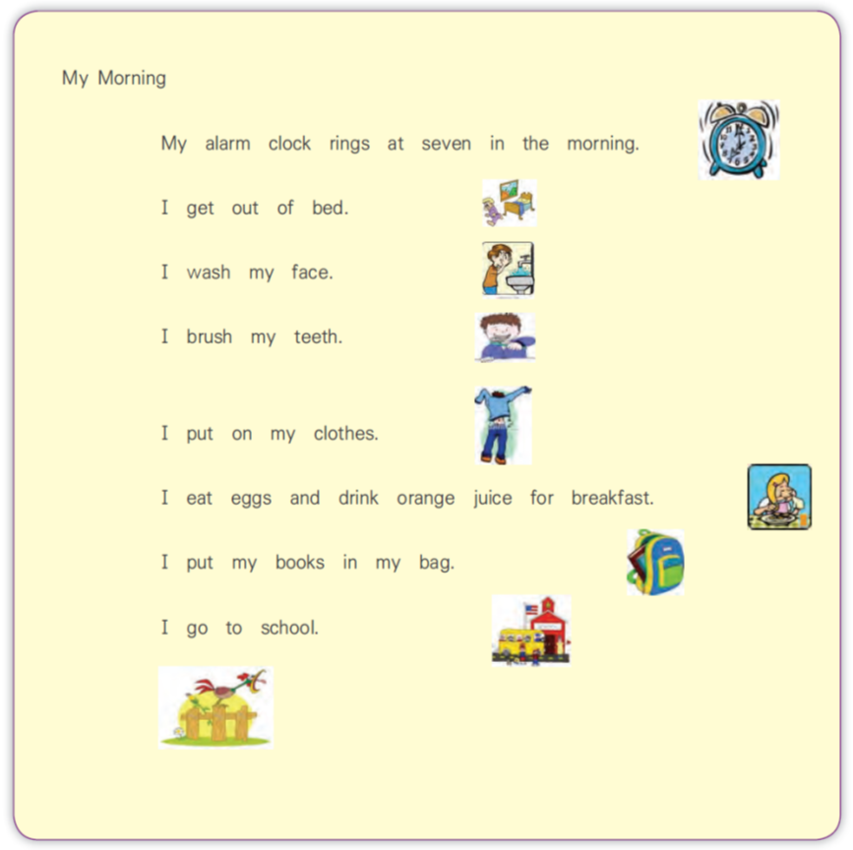

a. eat b. brush c. ring d. wash

23. I ………… my teeth.



a. ring b. brush c. wash d. put

24. I …………. on my clothes.



a. get out b. brush c. put d. wash

25. I …….. eggs and ……… orange juice for breakfast.



a. eat, put b. eat, drink

c. drink, eat d. put, drink

26. I ……….. my books in my bag.



a. put b. get out c. wash d. ring

Read the passage and fill the letters in the blanks from the given words 27-30.

a. scientist

b. Udonthani

c. shopping

d. twelve

e. April

My name is Catherin. I am (27)……….. years old. I live in (28)……………….. . I study at Sawasdee School. I like (29)………………… . In the future I want to be a (30)…………………. .

**Good luck**

PEOPL206

**เฉลยแบบทดสอบก่อนเรียน**

|  |  |  |  |  |
| --- | --- | --- | --- | --- |
| **1** | **c** |  | **16** | **b** |
| **2** | **d** |  | **17** | **a** |
| **3** | **b** |  | **18** | **d** |
| **4** | **d** |  | **19** | **b** |
| **5** | **d** |  | **20** | **c** |
| **6** | **b** |  | **21** | **d** |
| **7** | **d** |  | **22** | **d** |
| **8** | **c** |  | **23** | **b** |
| **9** | **c** |  | **24** | **c** |
| **10** | **b** |  | **25** | **b** |
| **11** | **c** |  | **26** | **a** |
| **12** | **d** |  | **27** | **d** |
| **13** | **a** |  | **28** | **b** |
| **14** | **b** |  | **29** | **d** |
| **15** | **c** |  | **30** | **a** |

**แบบทดสอบวัดความสามารถในการอ่านและการเขียนคำศัพท์พื้นฐานภาษาอังกฤษ หลังเรียน จำนวน 30 ข้อ**

**แบบทดสอบหลังเรียน**

**การจัดการเรียนรู้การสอนอ่านและเขียนภาษาอังกฤษด้วยวิธีการสอนแบบ 3Ps**

**รายวิชา ภาษาอังกฤษ กลุ่มสาระการเรียนรู้ภาษาต่างประเทศ ชั้นประถมศึกษาปีที่ 6**

**คำชี้แจง** จงเลือกคำตอบที่ถูกที่สุดเพียงข้อเดียว ข้อสอบมีทั้งหมด 30 ข้อ 30 คะแนน เวลา 60 นาที

1. What is the opposite of “young”?

a. short b. old c. tall d. small

2. What word is the same meaning as ‘Octopus’?

a. shell b. rock c. squid d. fish

3. Nana: What is this?

Tina: ……………. .

a. That is an orange fish. b. This is a orange fish.

c. That is a orange fish. d. This is an orange fish.

4. …………………. It to me.

a. Giving b. Give c. Gave d. Gived

5. Find which one of four sentences does not belong.

a. Put your books on the floor. b. Close your eyes.

c. Take your shoes off. d. Don’t speak loudly.

6. Don’t …………… away. Please ………………. For me.

a. runs, waits b. running, waiting

c. run, wait d. runed, waited

7. You are dirty. ………………. .

a. Don’t take a shower b. Takes a shower

c. To take a shower d. Take a shower

8. Don’t …………………… to me like that.

a. speaked b. to speak c. speaks d. speak

Look at the map and answer the questions 9-12.



9. Teacher: Where is the school?

Student: …………………… .

a. It’s in front of the supermarket. b. It’s behind the supermarket.

c. It’s next to the supermarket. d. It’s opposite the supermarket.

10. A: Where is the park?

B: ………………… .

a. It’s in front of the police station. b. It’s behind the police station.

c. It’s next to the police station. d. It’s opposite the police station.

11. Choose the correct answer.

a. The hospital is behind the bank.

b. The bank is in front of the supermarket.

c. The police station is near the school.

d. The park is opposite the bank.

12. Choose the wrong answer.

a. The supermarket is opposite the hospital.

b. The police station is next to the park.

c. The park is behind the hospital.

d. The supermarket is in front of the school.

Direction: Choose the best answer to complete from the questions 13-16.

(เลือกคำตอบที่สมบูรณ์ที่สุดจากคำถาม)

Peter’s holiday

Peter’s uncle is the farmer. He lives in the country. Every spring, Peter’s father drives his family to the farm to stay there for a week. Every day, Peter get up very early because he love working on the farm. His first job is to help his uncle with the cows. They take them to the milking house. After that, he goes to the hen house and gets the eggs. At half past eight, Peter and his uncle sit in the kitchen and eat a big breakfast.

13. Where does he live?

a. farm b. country c. hospital d. school

14. What’s Peter’s uncle job?

a. teacher b. driver c. farmer d. doctor

15. What does Peter do first in the morning?

a. To help his uncle with the cows.

b. To the farm to stay there for a week.

c. To eat a big breakfast with his uncle.

d. To get up early and take a shower.

16. Does Peter get up late or early?

a. No, he doesn’t. b. Yes, he does.

c. Yes, he doesn’t. d. No, he does.

Direction: Read the passage and fill the letters in the blanks from the given words 17-19

My name is Edwin Chan. I am thirty-one years old. I am a university student. I was born on August 22th. My address is 32 Mangrove Road. Singapore. My girlfriend and I will fly to Thailand on our holiday for two weeks.

I will arrive in Bangkok on June 18th. We plan to stay at Royal Benja Hotel, on Sukhumvit Road, Bangkok, for a week. My room number is 2810.

This hotel is very good, but expensive. I have to pay 2,400 baht for a night. After that we will go to Nongkhai. My Thai number is 08-2543-7648.

a. Student

b. Nongkhai

c. Bangkok

d. Singapore

Hotel Registration Form

17. Coming From :_______________________________________________

18. Profession:___________________________________________________

19. Next Destination :_____________________________________________

20. Read the card and answer the question.

A hundred hearts would be too few

To carry all my love for you…

You are the best, my love.

I love you.

When do you send this card?

a. Christmas b. Halloween

c. Thanksgiving d. Valentine’s Day

21. Read the card and answer the question.

What is this card?

a.Valentine’s day b. Birthday

c. Mother’s day d. Wedding

22. I …………. on my clothes.



a. get out b. brush c. put d. wash

23. I ……….. my books in my bag.

a. put b. get out c. wash d. ring

24. I …………. My face.



a. eat b. brush c. ring d. wash

25. I …….. eggs and ……… orange juice for breakfast.

a. eat, put b. eat, drink

c. drink, eat d. put, drink

26. I ………… my teeth.



a. ring b. brush c. wash d. put

Read the passage and fill the letters in the blanks from the given words 27-30.

a. scientist

b. Udonthani

c. shopping

d. twelve

e. April

My name is Catherin. I am (27)……….. years old. I like (28)………………… . I live in (29)……………….. . I study at Sawasdee School. In the future I want to be a (30)…………………. .

**Good luck** PEOPL206

**เฉลยแบบทดสอบหลังเรียน**

|  |  |  |  |  |
| --- | --- | --- | --- | --- |
| **1** | **b** |  | **16** | **b** |
| **2** | **c** |  | **17** | **d** |
| **3** | **d** |  | **18** | **a** |
| **4** | **b** |  | **19** | **b** |
| **5** | **d** |  | **20** | **d** |
| **6** | **c** |  | **21** | **c** |
| **7** | **d** |  | **22** | **c** |
| **8** | **d** |  | **23** | **a** |
| **9** | **b** |  | **24** | **d** |
| **10** | **c** |  | **25** | **b** |
| **11** | **d** |  | **26** | **b** |
| **12** | **c** |  | **27** | **d** |
| **13** | **b** |  | **28** | **c** |
| **14** | **c** |  | **29** | **b** |
| **15** | **a** |  | **30** | **a** |

**ตารางที่ ค.1**

*แสดงคะแนนเฉลี่ย ส่วนเบี่ยงเบนมาตรฐานและคะแนนเฉลี่ยคิดเป็นร้อยละของคะแนนก่อนเรียนและหลังเรียนชั้นประถมศึกษาปีที่ 6*

|  |  |  |  |  |
| --- | --- | --- | --- | --- |
| เลขที่ | คะแนนทดสอบ  ก่อนเรียน (30) | คะแนนทดสอบ  หลังเรียน (30) | ผลต่าง  ของคะแนน (D) | ผลต่าง  ยกกำลังสอง |
| 1 | 18 | 29 | 11 | 121 |
| 2 | 8 | 19 | 11 | 121 |
| 3 | 16 | 27 | 11 | 121 |
| 4 | 7 | 18 | 11 | 121 |
| 5 | 16 | 28 | 12 | 144 |
| 6 | 9 | 19 | 10 | 100 |
| 7 | 12 | 25 | 13 | 169 |
| 8 | 15 | 28 | 13 | 169 |
| 9 | 8 | 18 | 10 | 100 |
| 10 | 19 | 29 | 10 | 100 |
| 11 | 10 | 19 | 9 | 81 |
| 12 | 10 | 16 | 6 | 36 |
| 13 | 11 | 24 | 13 | 169 |
| 14 | 17 | 29 | 12 | 144 |
| 15 | 6 | 15 | 9 | 81 |
| 16 | 8 | 19 | 11 | 121 |
| 17 | 14 | 28 | 14 | 196 |
| 18 | 7 | 17 | 10 | 100 |
| 19 | 7 | 15 | 8 | 64 |
| 20 | 9 | 17 | 8 | 64 |
| 21 | 19 | 30 | 11 | 121 |
| 22 | 16 | 28 | 12 | 144 |
|  | 262 | 497 | 235 | 2,587 |
|  | 11.91 | 22.59 | 10.68 | 117.59 |
| S.D. | 4.40 | 5.51 | 19.1 | 39.37 |
| ร้อยละ | 39.70 | 75.30 | 35.61 | 391.97 |